# Lab 1 - Write a C# Program print your Name and Address.

## Source Code:

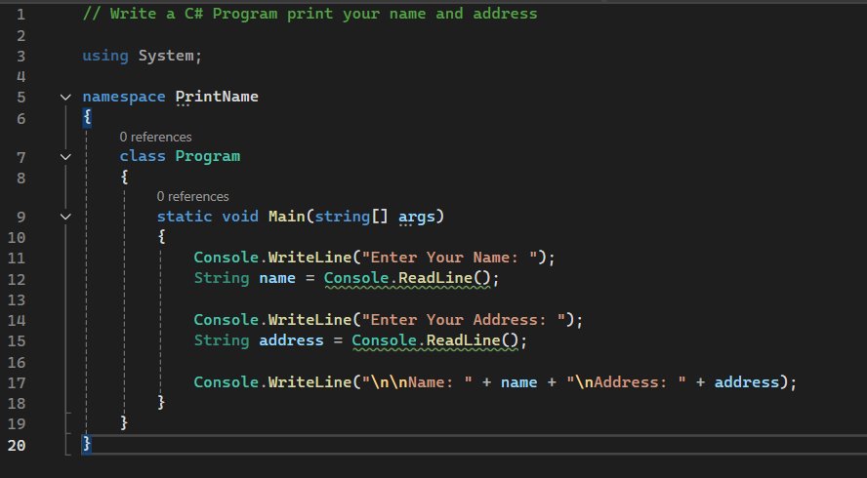

## Output:

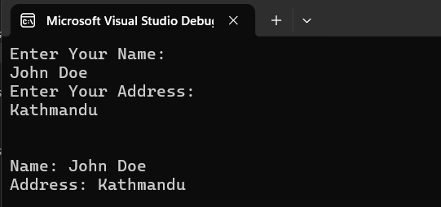

# Lab 2 - Write a C# Program to Print an Integer Entered by User.

## Source Code:

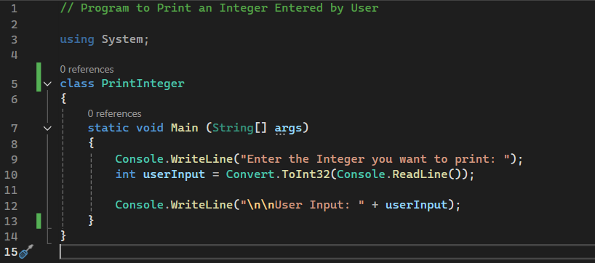

## Output:

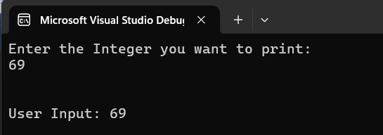

# Lab 3 - Write a C# Program to Multiply two Floating Point Numbers Entered by User.

## Source Code:

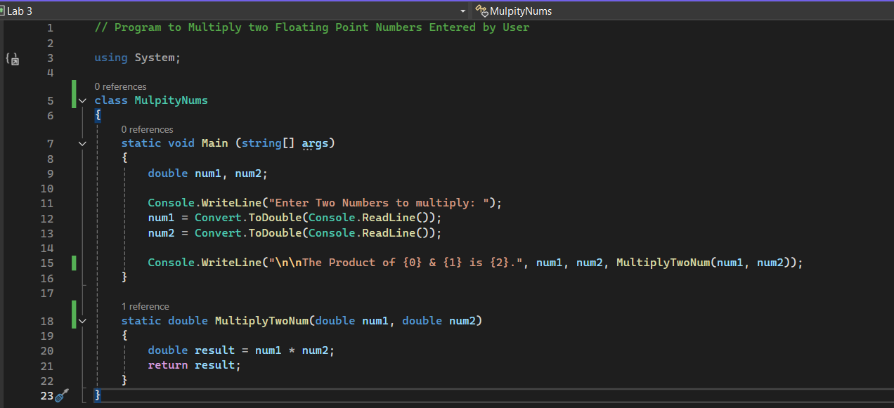

## Output:

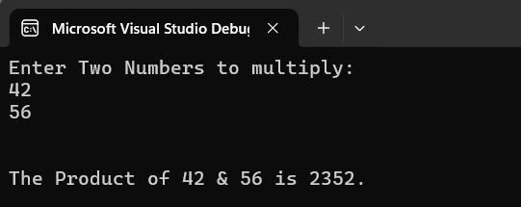

# Lab 4 - Write a C# Program to Calculate the Simple Interest.

## Source Code:

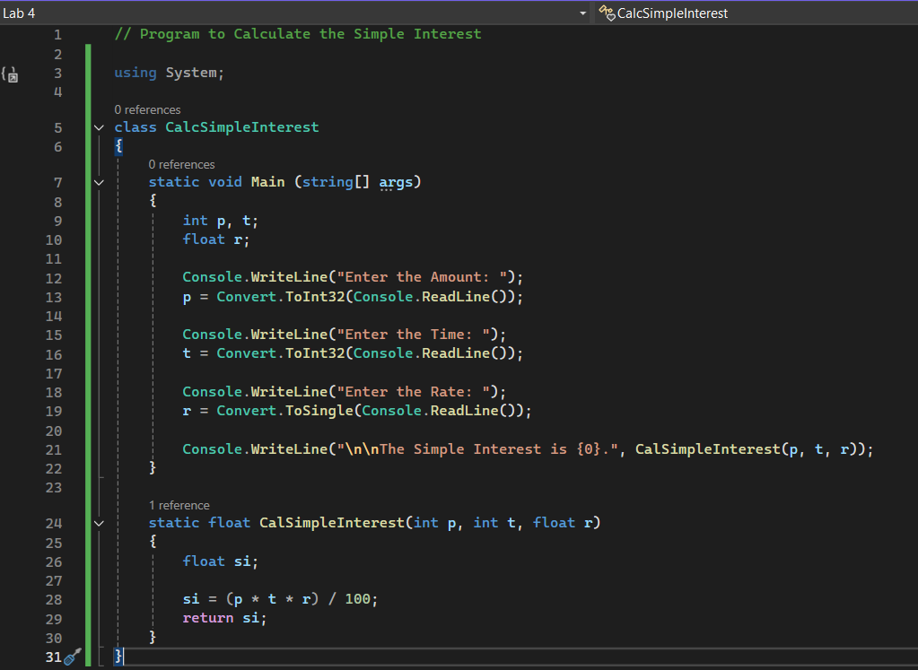Output:

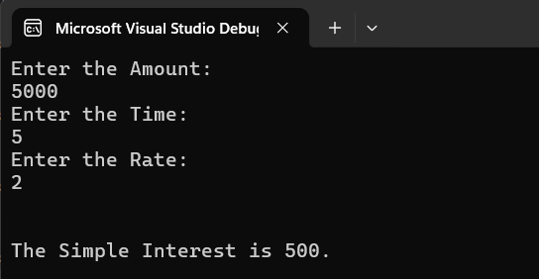

# Lab 5 - Write a C# Program to Calculate Area and Perimeter of Circle.

## Source Code:

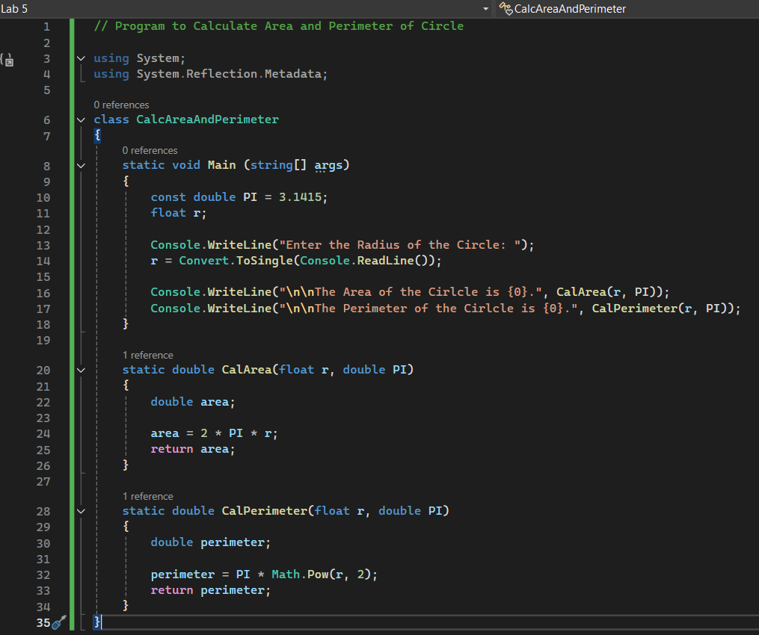

## Output:



# Lab 6 - Write a C# Program to Count Number of Words in a String.

## Source Code:

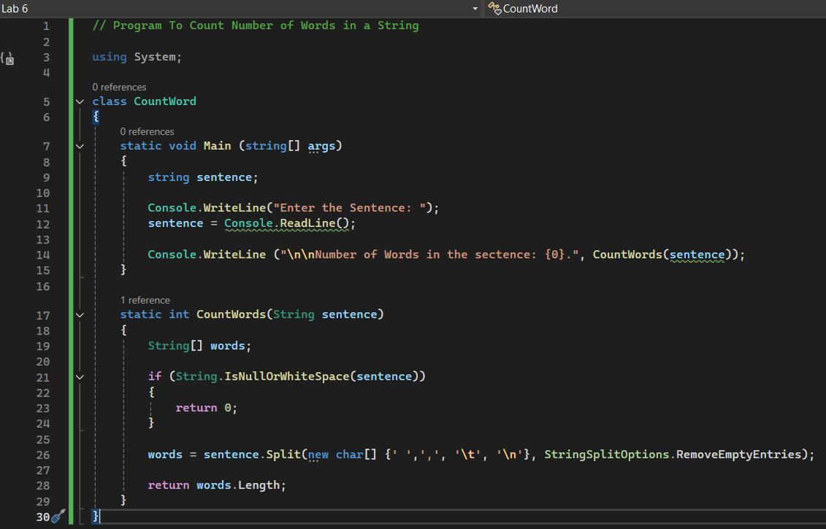

## Output:

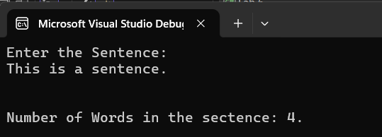

# Lab 8 - Write a C# Program to Print all prime numbers in an interval (i.e. from 5 to 20).

## Source Code:

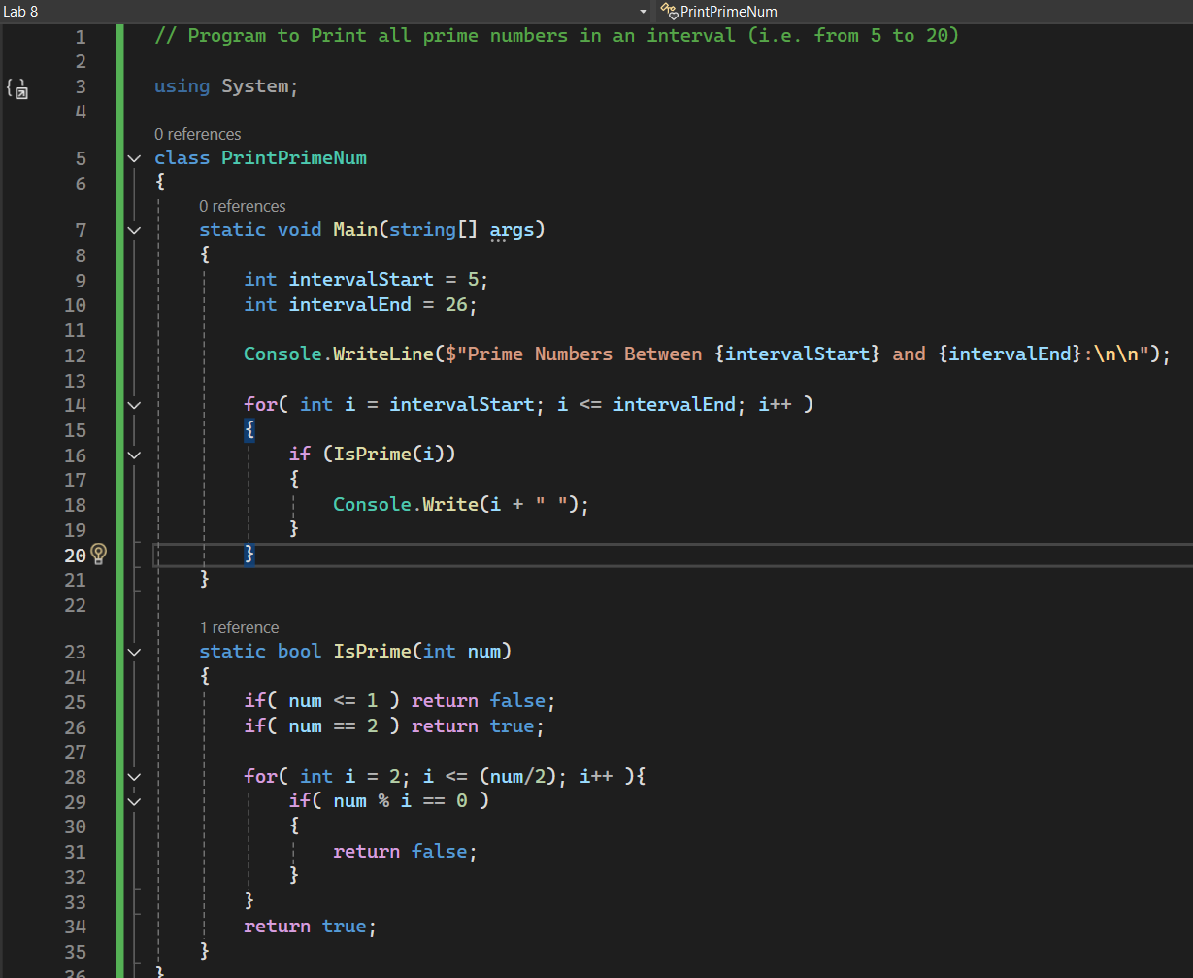

## Output:

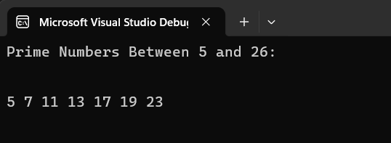

# Lab 9 - Write a C# Program to Find greatest number among 3 numbers using conditional operator.

## Source Code:

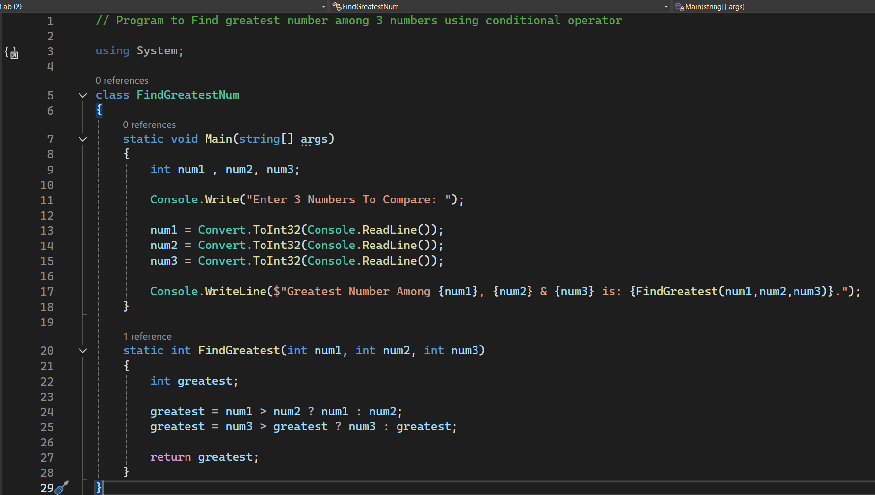

## Output:

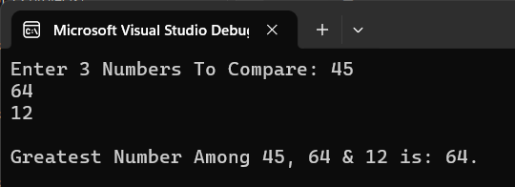

# Lab 10 - Write a C# Program to calculate library fine.

## Source Code:

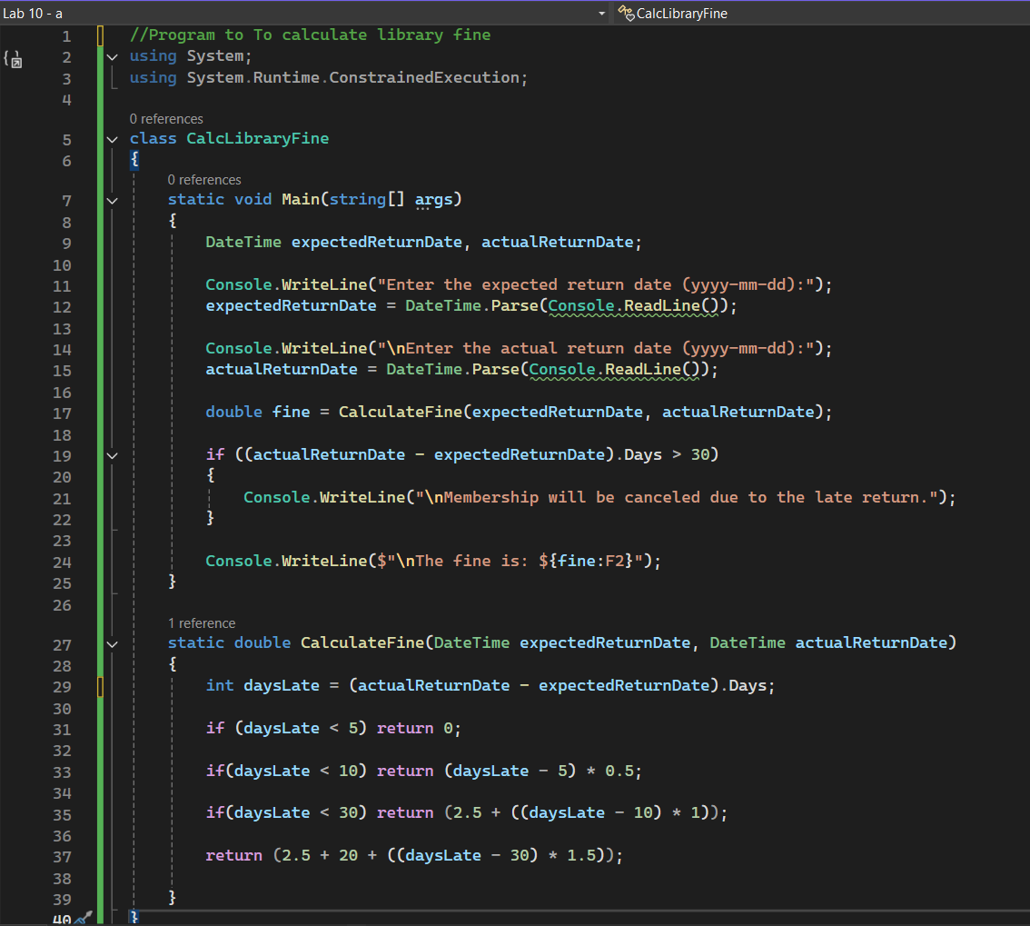

## Output:

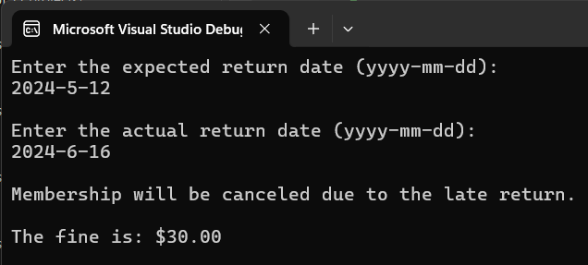

# Lab 11 - Write a C# Program to Find min and max number in an array.

## Source Code:

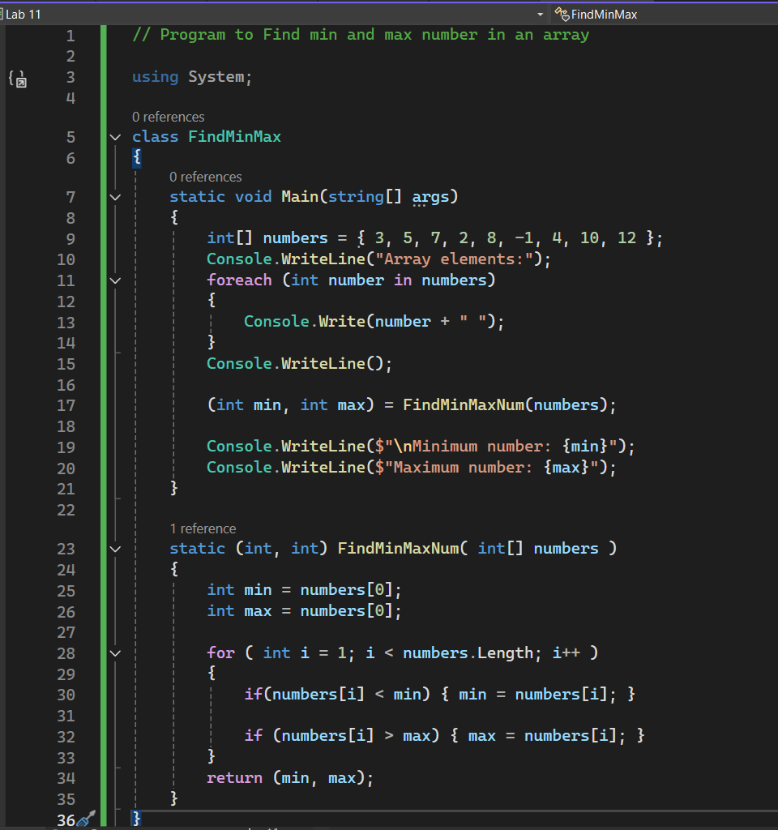

## Output:

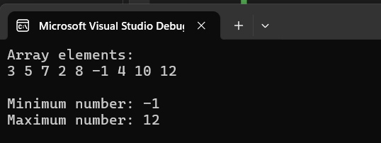

# Lab 12 - Write a C# Program to Find the factorial of a number.

## Source Code:

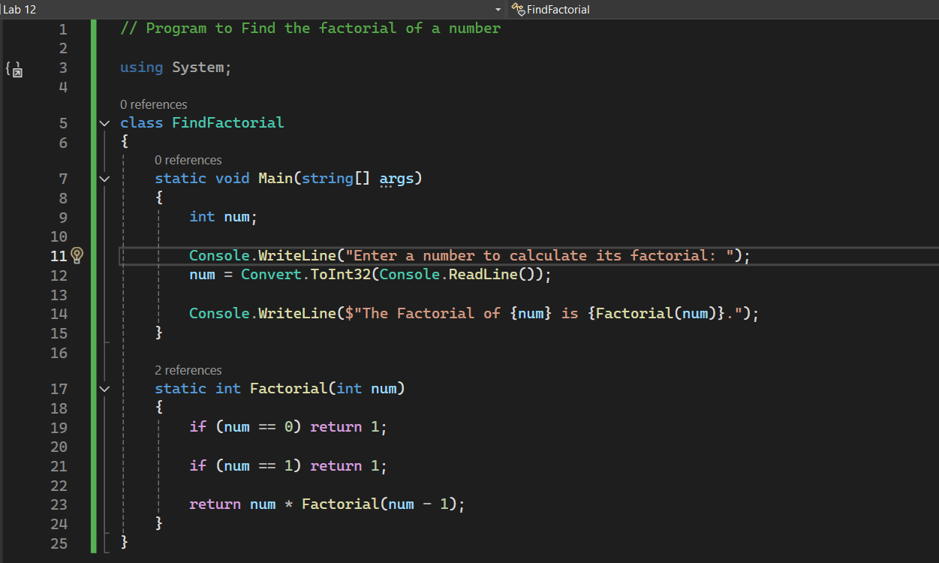

## Output:

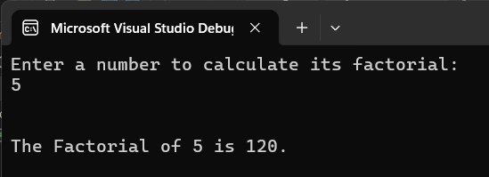

# Lab 13 - Write a C# Program to Find the longest word in a string array.

## Source Code:

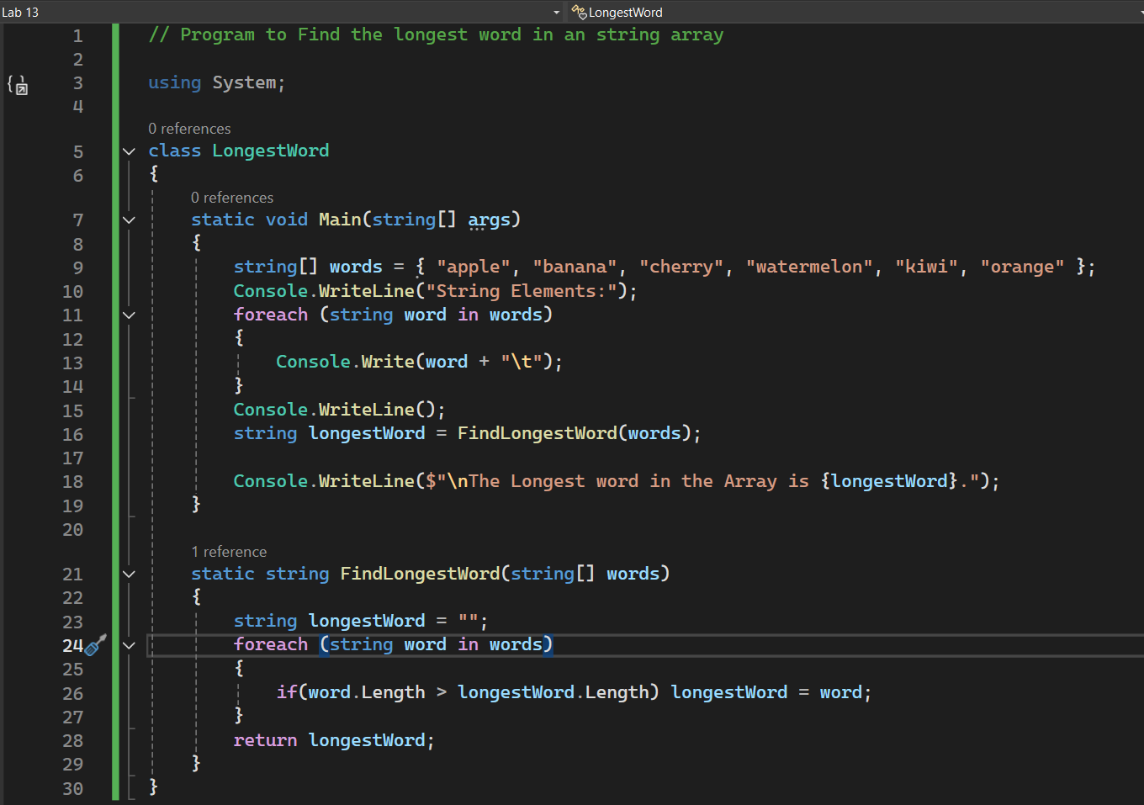

## Output:

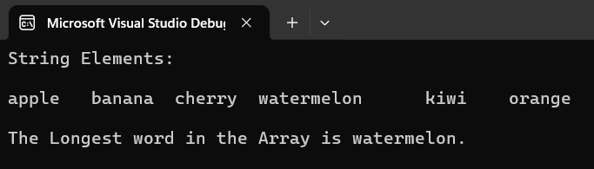

# Lab 14 - Create a GUI login form and validate it with username as your first name and password as your surname. It should also have Clear Fields Option.

## Source Code:

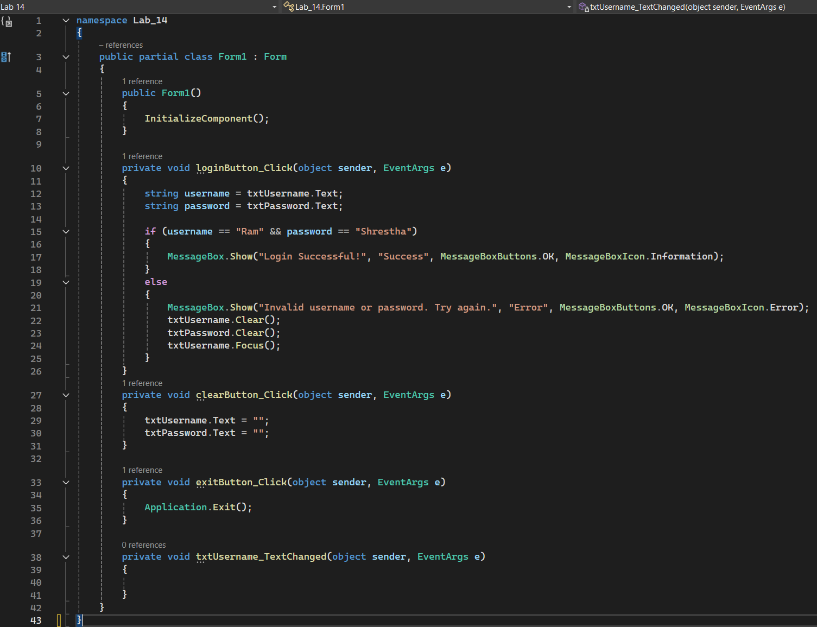

## Output:

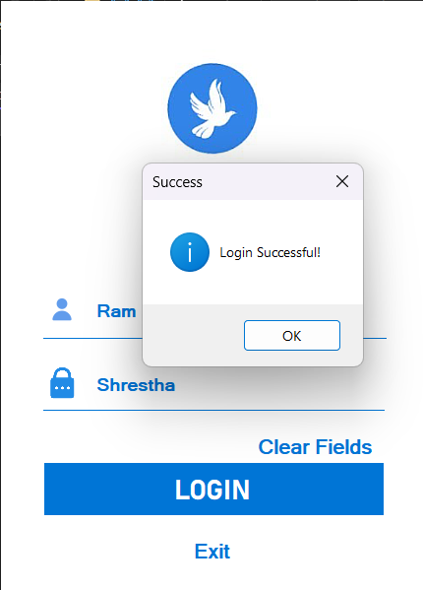

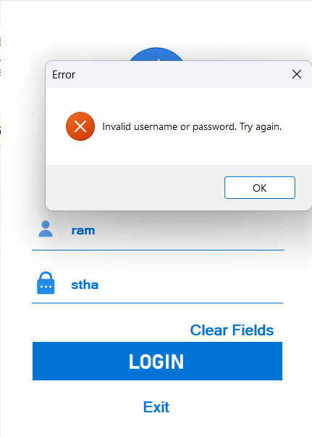

# Lab 15 - Design a GUI based Calculator which can perform basic arithmetic operations. Also create a Clear button to clear the answer.

## Source Code:

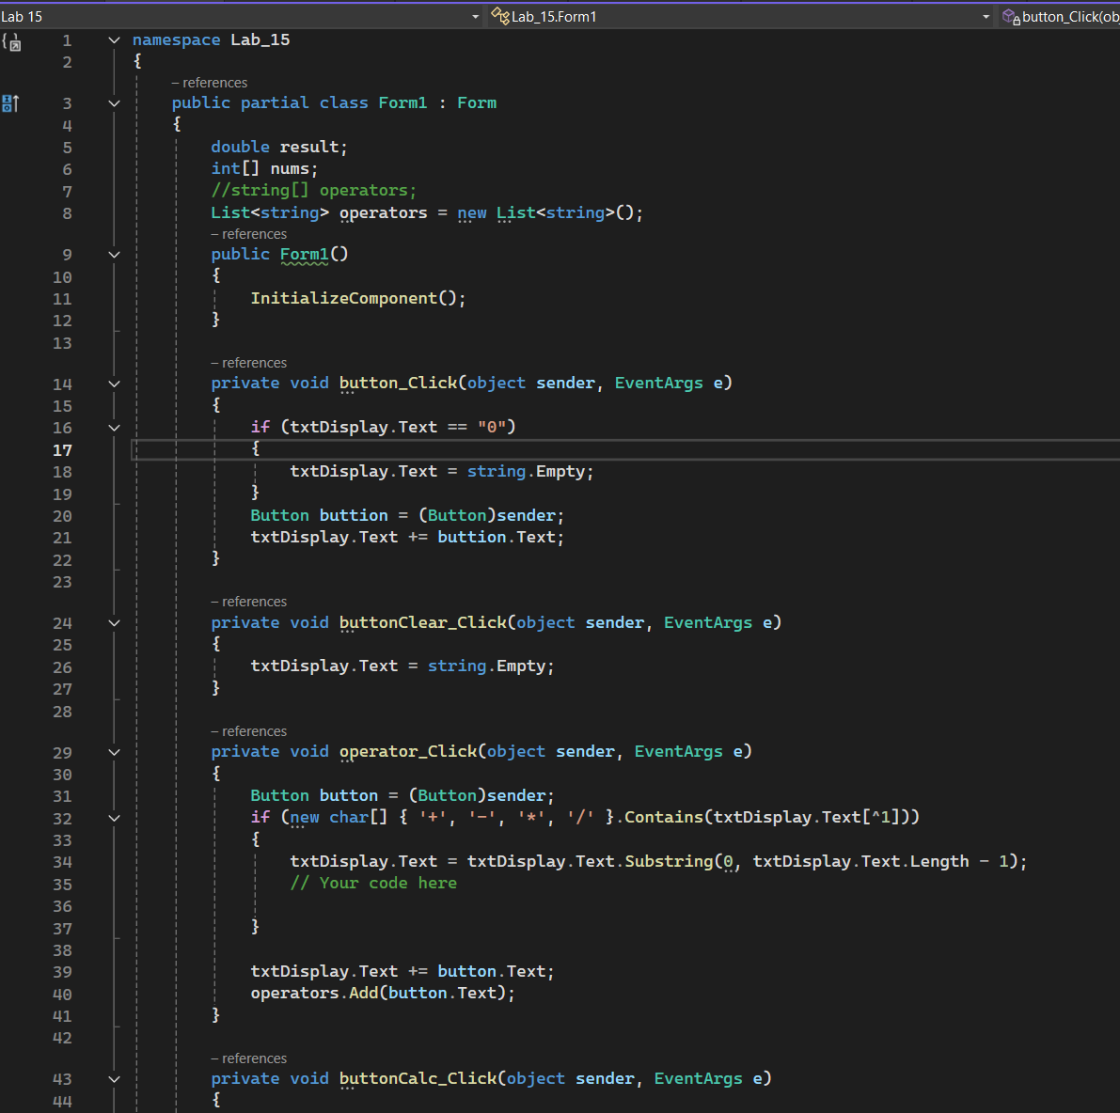

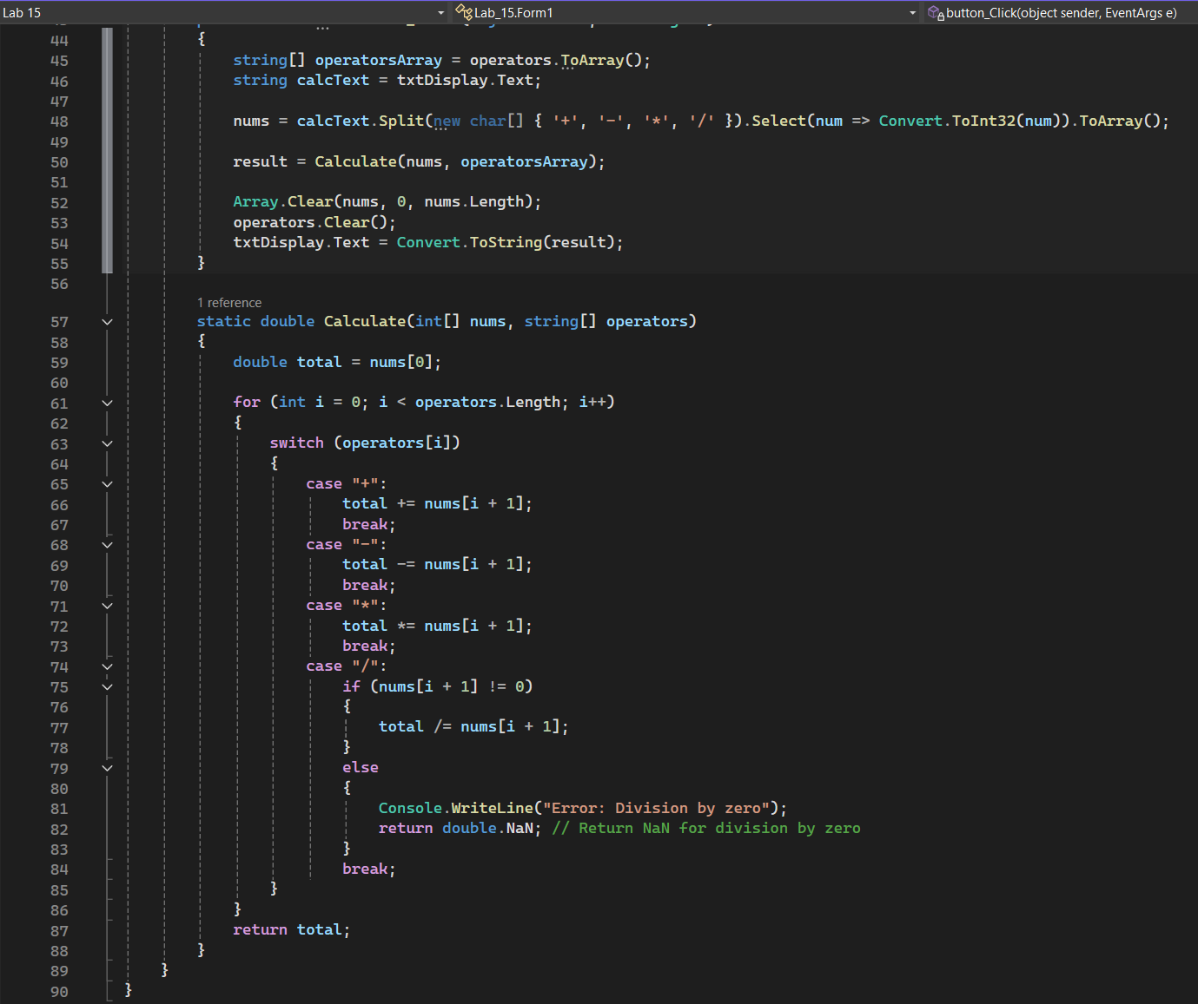

## Output:

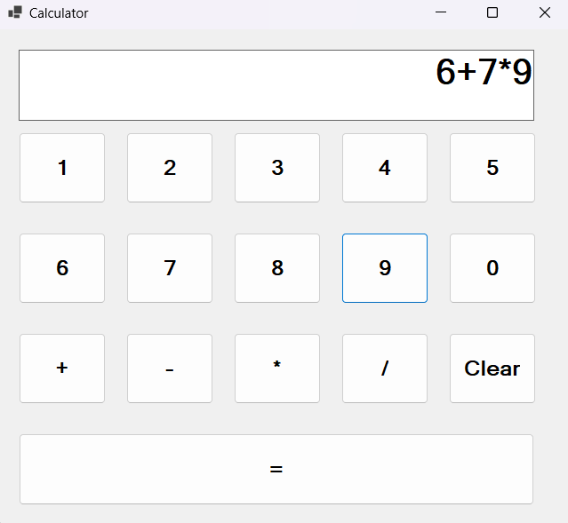

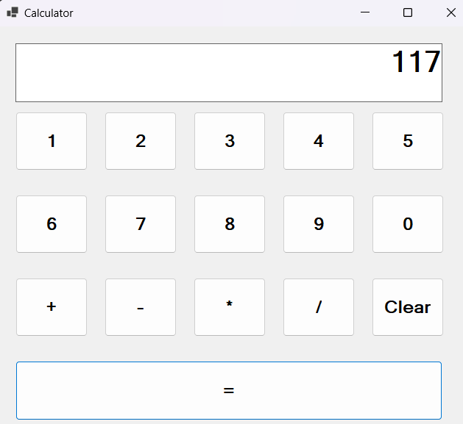

# Lab 16 - Write a C# Program to create a class named Bird and display the color of Crow, Pigeon and Penguin.

## Source Code:

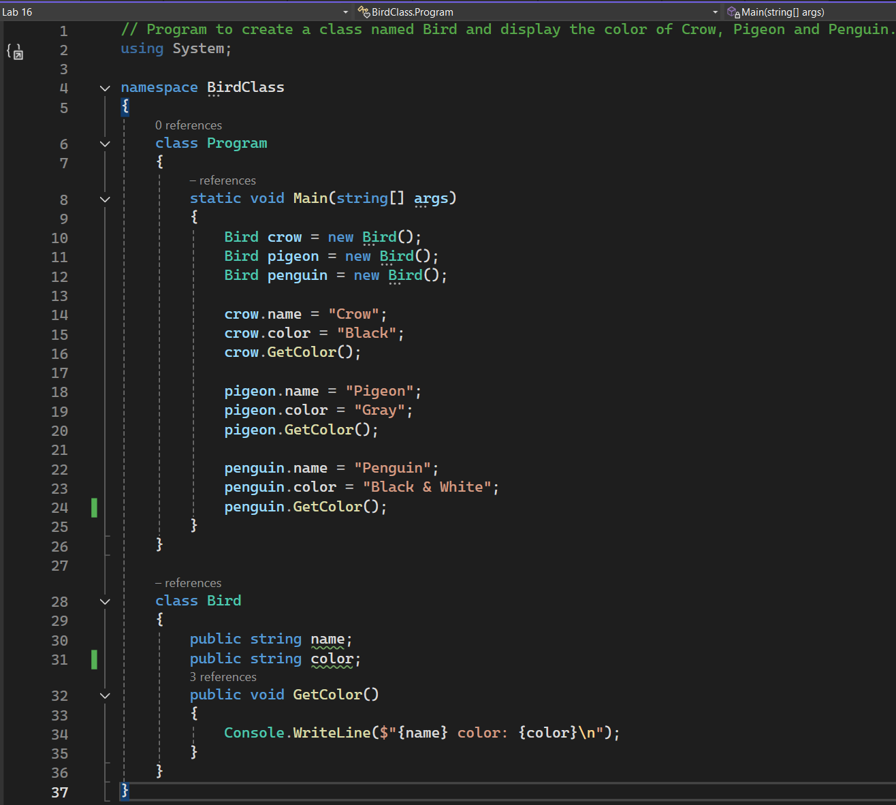

## Output:

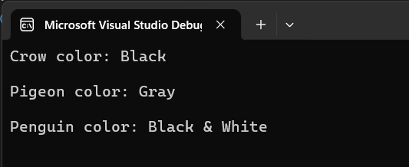

# Lab 17 - Create a parameterized constructor to display the milage of three different models of Car.

## Source Code:

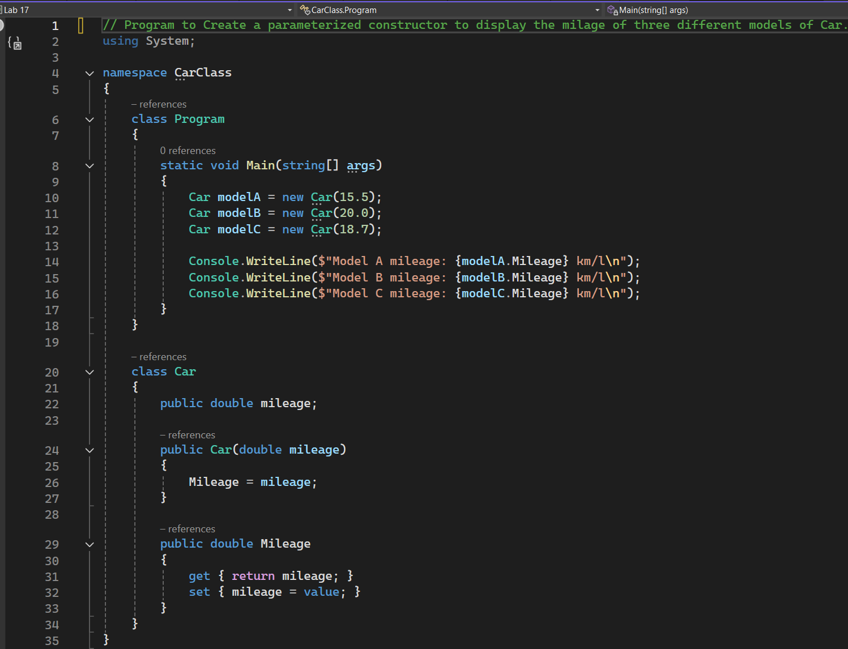

## Output:

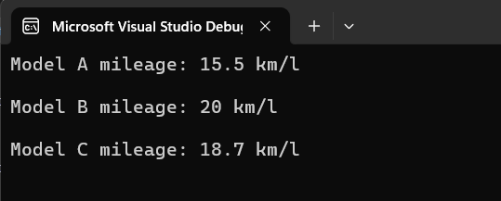

# Lab 18 - Write a program to illustrate internal protected access modifier in C#.

## Source Code:

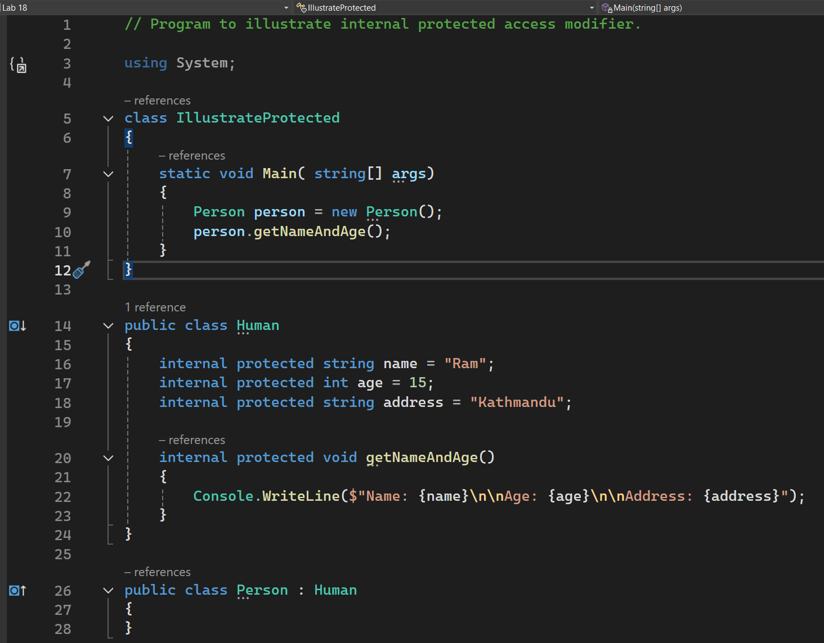

## Output:

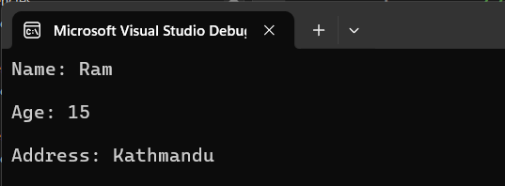

# Lab 19 - Write a C# Program for automatic Properties.

## Source Code:

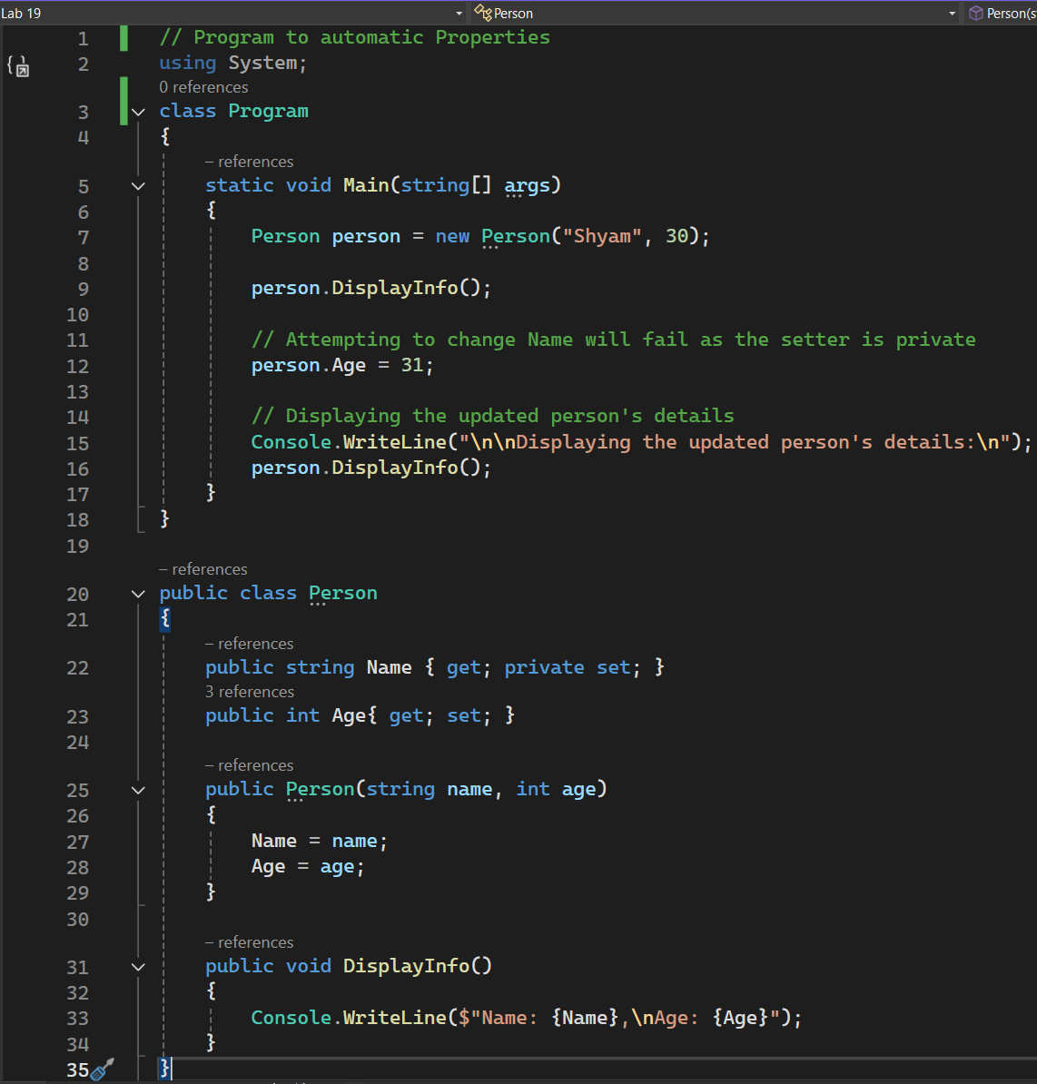

## Output:

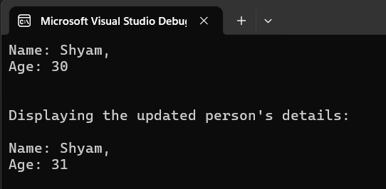

# Lab 20 - Write a Program in C# to illustrate working of this keyword.

## Source Code:

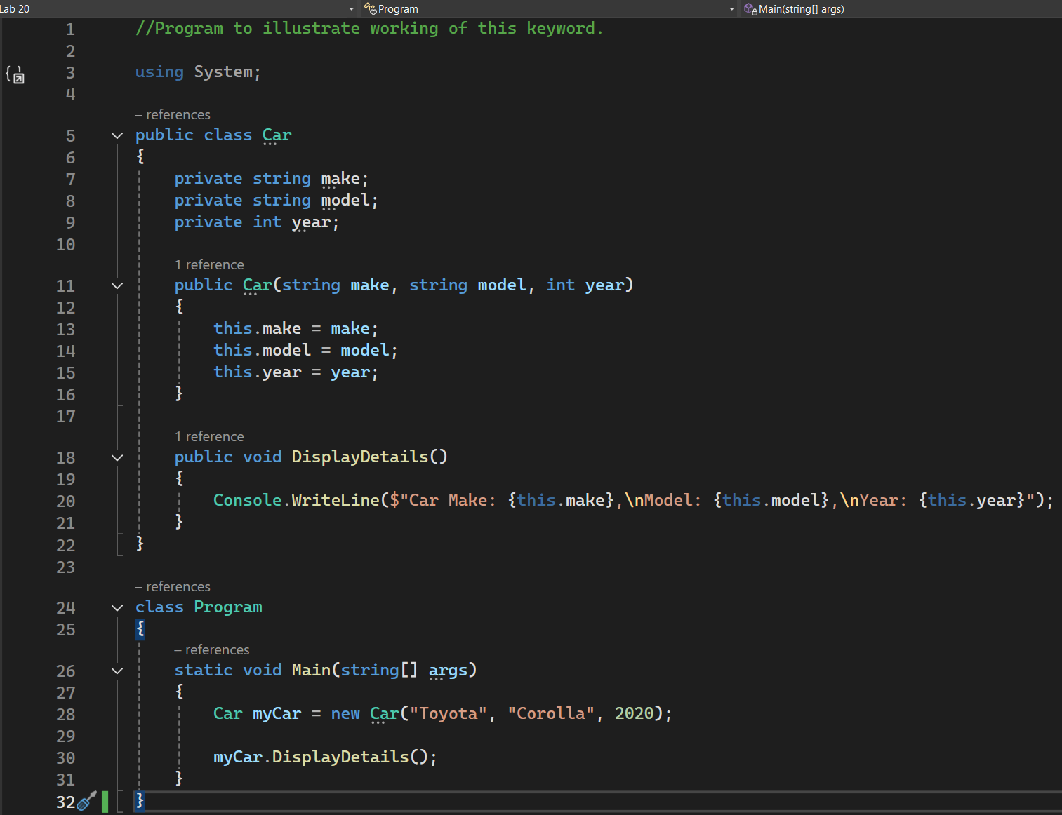

## Output:

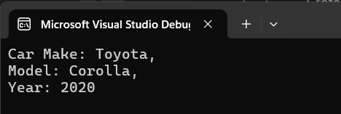

# Lab 21 - Give an example of Indexers in C#.

## Source Code:

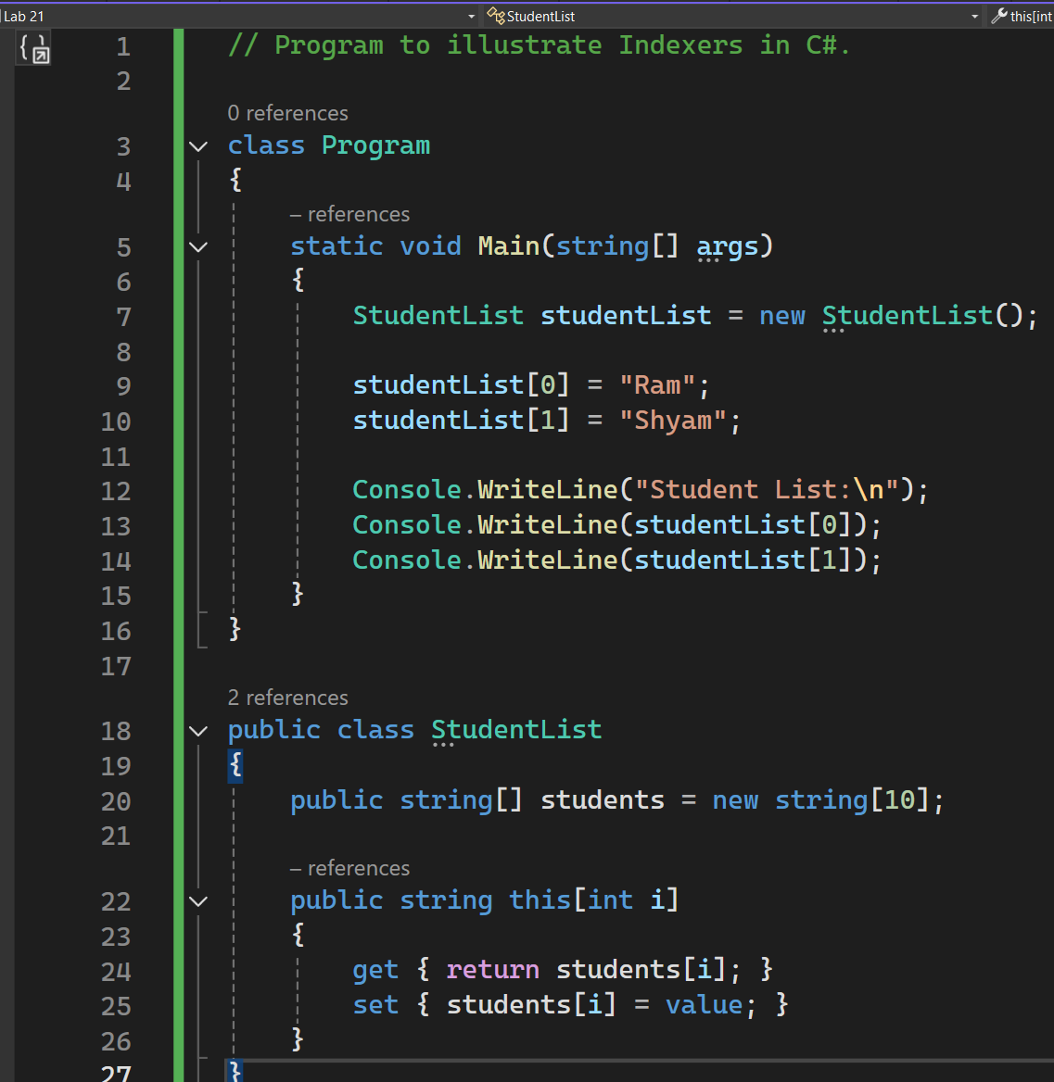

## Output:

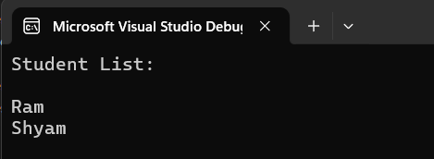

# Lab 22 - Give an example of static constructors and static class in C#.

## Source Code:

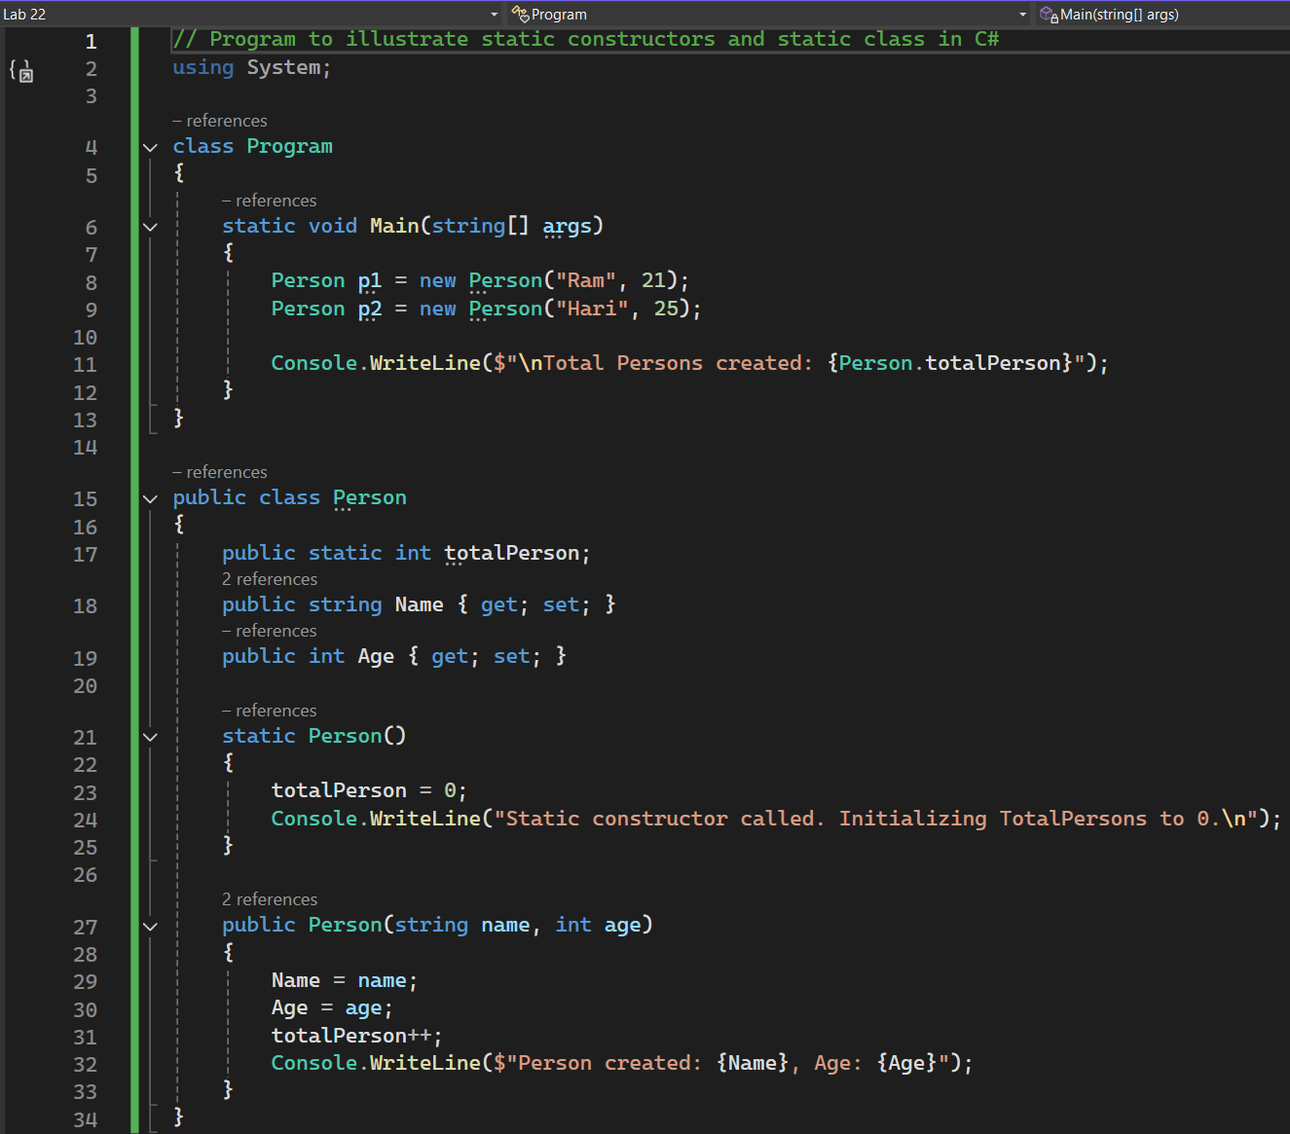

## Output:

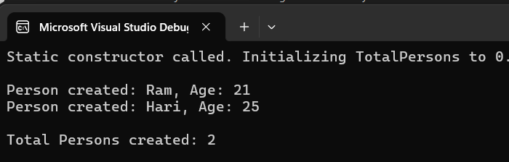

# Lab 23 - Write a C# Program to illustrate multilevel inheritance.

## Source Code:

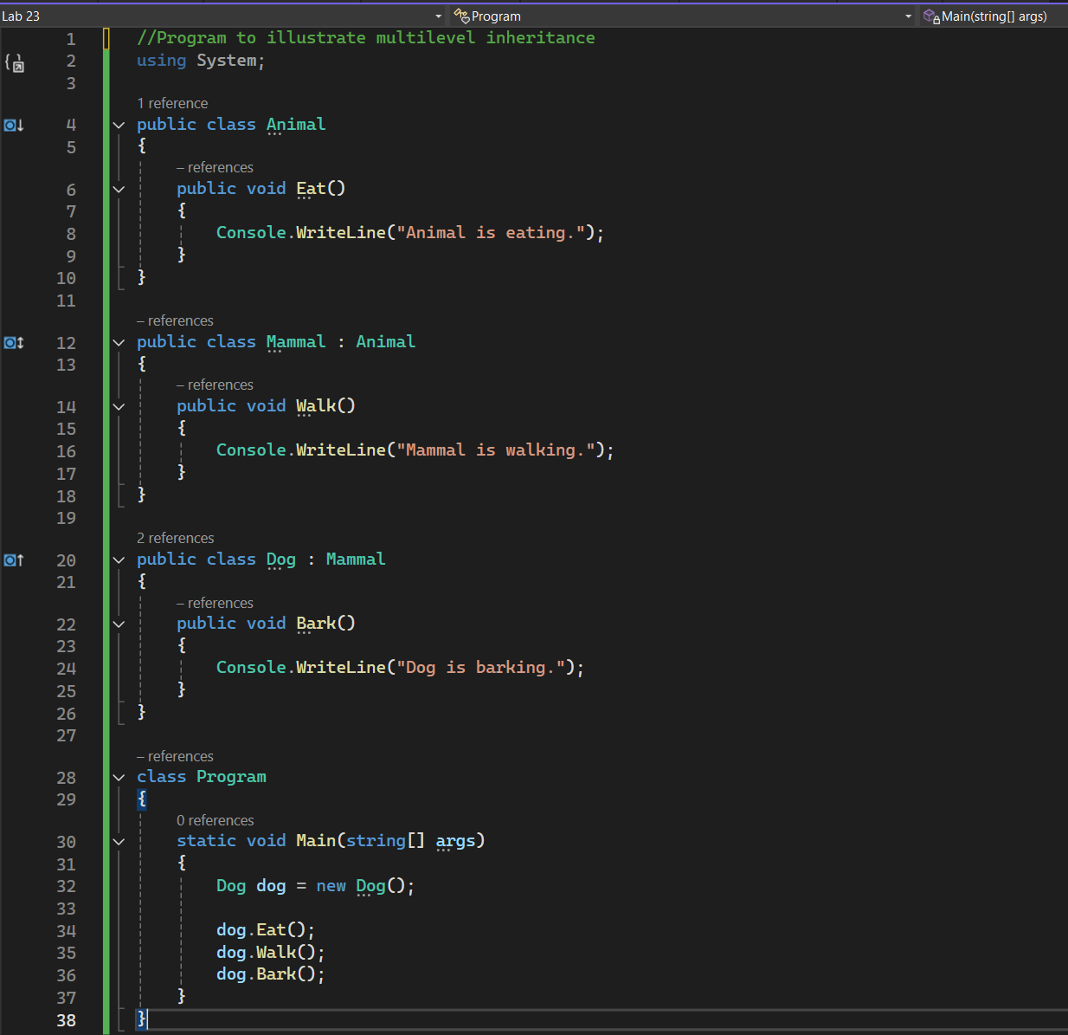

## Output:

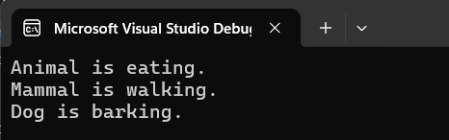

# Lab 24 - Write a C# Program to illustrate multiple inheritance using interfaces.

## Source Code:

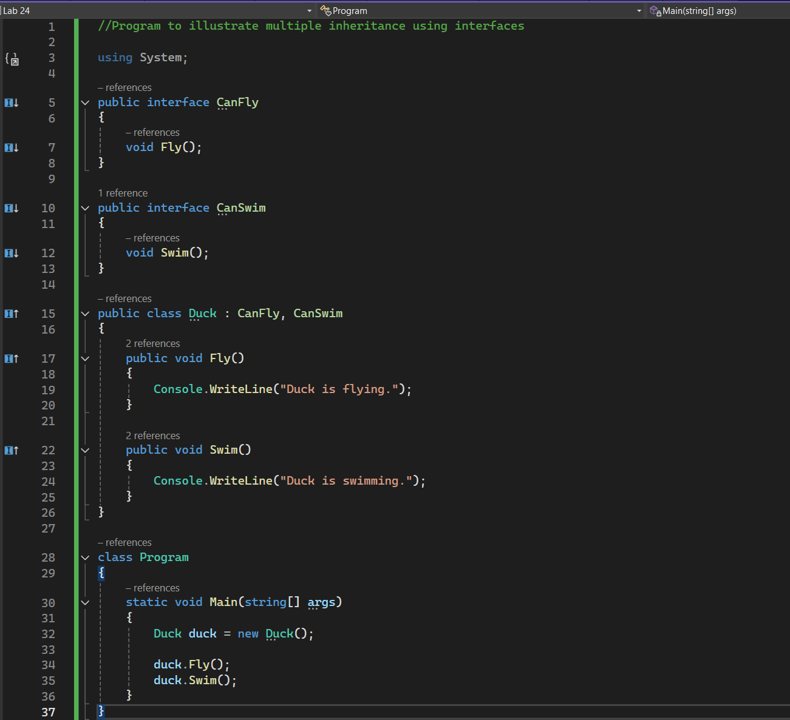

## Output:

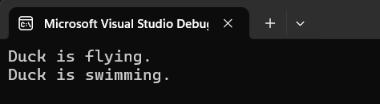

# Lab 25 - Write a Program using virtual method to achieve dynamic binding in C#.

## Source Code:

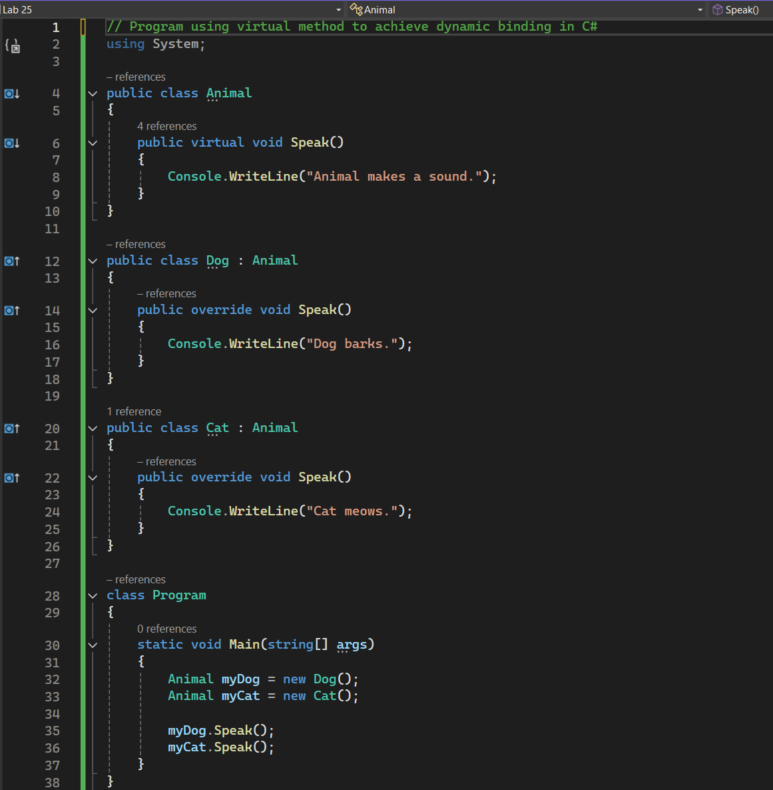

## Output:

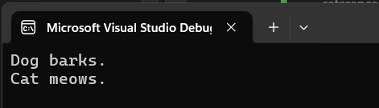

# Lab 26 - Give an example of how Delegates works in C# with an example.

## Source Code:

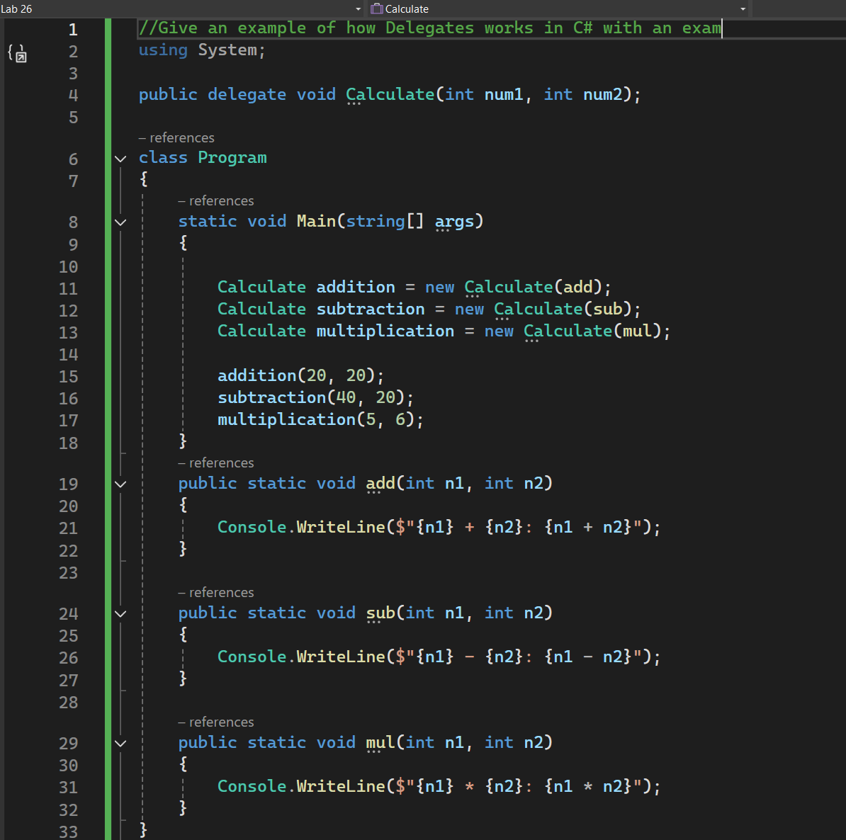

## Output:

